Database Design 6 : Logical Modelling

Learning outcomes: at the end of this section, you should be able to

- Explain the basic modelling concepts: objects and associations, multiplicity, generalisation/specialisation, inheritance
- Apply modelling concepts to represent real world systems/organisations
- Explain, using examples, problems with modelling (disadvantages).
- Translate a logical model for use in a database system (relational)

Logical Design: (Relational model v’s object model)

A model is a logical high level way of organising a view (or description) of a system. To model something is to create a representation of a real world system. There are many different models depending on the type of system you are dealing with. In Computing/IT there are 2 main models of interest to DBS (Relational model & Object model)

Most Database Systems use a particular model called the relational model where the only concept used to describe and design the system is a table; that is, database designers can only use tables when organising the system to store data. These databases are called relational database systems (RDBMS). Oracle, IBM (DB2), Microsoft (SQL-Server), MySql, Ingres all use the relational model. In other words, you don’t use entities, or objects, just tables. The only real world systems that can be modelled in way are record based data processing systems. That means, a database table can only store records.

One problem with the relational model is that not all systems are data processing systems like a database. So how might we describe these other systems where using tables and the relational model may not be suitable? We need another model (another way of organising and representing the system).

A second problem with the relational model is that it is not initiative. The world is complex, yet every fact to be represented must be stored as a record in a table. Using just one concept (a table) to describe the meaning of a system is inadequate. It is very difficult to derive the meaning of a system by just looking at table column definitions; that is, it doesn’t describe or model the world very well.

The most popular general purpose Business and IT model currently in use is an object oriented model i.e. designers use objects when organising/describing the system.

This model must depict the essential details of the system. It must depict the system in a general way, so that the model (once finished) can be applied to many different types of systems and organisations (one of which might be a database).

Model

translate
Object Relational (Table)

An important aspect of this general modelling approach is that we should be able to transform/translate a general object oriented model into the relational model. The logical model will capture the essential elements of the system. If the model suits a database (record) based implementation then we can transform ‘across’ into our database design (using tables to store data). This is an important learning outcome in this module.

Unified Modelling Language (UML) has developed as a standard way of describing this object based system. UML is a large, complex collection of notations (diagrams) for describing the different aspects of analysis and design. UML captures the properties and characteristics of the elements of the system.

UML also can capture things like behaviour, external interactions, implementation details etc.
Database design does not require these additional aspects. Therefore, for database design purposes, we are only interested in a particular section of UML, namely Class diagrams.

A class diagram models (describes) the structural aspects of the system. Class diagrams describes
- the basic elements of the system (called entity or object classes)
- the associations or relationships between the entities/object classes.

Modelling has developed over many years. Before UML developed the notion of class diagrams, there was a modelling methodology called ER modelling (Entity Relationship). This was commonly used in database systems design. The two models differ slightly (e.g. in terms and notation used), however they are very similar in nature.

- We will use the terms entity and object interchangeably.
- We will use the terms relationship and association interchangeably.

So, in database, designers may use
- a methodology tied to the data structure used (Normalisation and tables in the relational model) or
- we can use a generic implementation independent design methodology (modelling using objects).

As we will see, even though the concepts and terminology are different, in reality both normalisation and modelling are doing similar things i.e. organising data into elements and identifying links and constraints between elements. If a designer uses a high level object model to design the system, we should be able to translate it easily into a relational model for implementing in an RDBMS.

The advantages of modelling using UML are, that it

- Is a recognised international standard for describing systems in a structured way
- It produces easily understandable documentation.
- It is useful in describing large systems (Enterprise level model)
- It is (relatively) non tech jargon, so managers can converse with tech personnel
- It is useful for projects involving groups of developers.
- It is also useful for projects that last for a long time / or that have ongoing development where different workers may be involved
- It can be easily transformed to implement a database

This methodology is particularly good for a new system where there may not be any real or existing data to use in helping the designer.

So, UML is an object modelling system that can be used for design.

Basic class diagram modelling concepts: Objects & Associations

Object / Entities Classes: may be a: Person, Place, Object, Event, or Concept

Type | Examples
Person | Employee, Student, Patient
Place | Store, Warehouse, State
Object | Machine, Automobile, Part
Event | Sale, Registration, Renewal
Concept | Account, Course, Result

How to identify object Classes?

Design Hint: Look for Nouns in a design specification.

Some (maybe all) nouns in the specification will be viable classes. But many models are over elaborate, containing too many invalid/useless objects.

How would you recognise a viable object? NB from a database perspective!

A simple rule from a database perspective: a viable class of objects will have

- many possible instances, each with
- a distinguishing key or identifying characteristic, as well as
- one or more other descriptive pieces of data.

Recall: In Design 2, we had an attribute called Room#, it was not until we realised that it was an lecturer office room# that it became apparent that we had a possible new object called ‘lecturer’. When we analysed further, we found an identifier (Lname) and a descriptive attribute (room#). So, now we have a viable class of objects called Lecturers.

Note: Diagrams and some definitions from Connolly & Begg support website for the modules recommended text book. NB: we will only use certain aspects of this diagram.
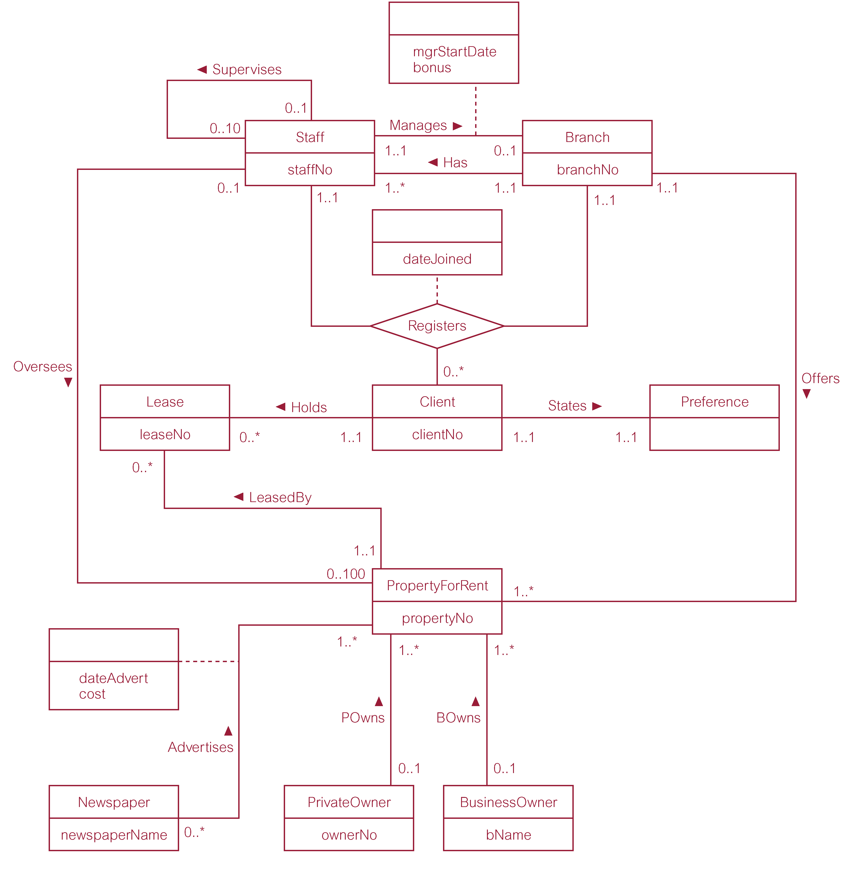

NB: Subtypes/ Supertype

Associations (aka Relationships)

A relationship is a meaningful association between (or among) entities.

Actions: look for verbs in the specification, e.g. orders, ships, buys, lends etc

Examples: Supplier Supplies Part(s); Customer Order Product(s); Student enrols Course(s)

Multiplicity of a relationship:

Multiplicity describes how the objects/entities participating in the relationship are related. It represents a constraint on a relationship. That is, it is not just a general relationship; it is a type of relationship that behaves in a very specific way. The constraint captures the meaning of the relationship.

Multiplicity in UML is a complex aspect of a relationship (see appendix for details).

We will examine a simplified version of multiplicity in this course. We will describe the multiplicity as either being *:* or N:M (many to many) or 1: * or 1:N (one to many)

For example, the association between Suppliers and Parts is described as having a many to many multiplicity denoted *.*, as

- Any one Supplier can supply many Parts; and
- Any one Part can be supplied by many Suppliers;

We will adopt a simplified diagram to describe the association between objects. Notice the simplified information on each link in the following version.

Supplier Supplies (*:*) Part

Example of 1:*

- Any one Owner can own many Properties; and
- Any one Property can be owned by only one Owner;

Owner Owns (1:*) Property

Note that limits (upper or lower) are not generally implemented in database design e.g. in large diagram look at Staff oversee 100 propertyforrent. The SQL Create table command does not implement this limit. It would have to be programmed in C++ or Java. A lower limit of 0 or 1 is a special case dealt with later. See appendix for Participation constraints on relationships.

Transformation of UML to table: Each object maps to a table; an N:M associations maps to a table (usually with composite key drawn from the linked object tables). 1:N association, no new table, just embed the Key of the object table on the 1 side into the object table on the N side.

In DB design we implement a 1:* association by burying the foreign key of the Many(*) into the table of the One side;

In other words, instead of a new table we just add an extra attribute into the Many table, this attribute is the foreign key to the one table. So in Design 2, CollegeDB, the Course table has an extra attribute Lname, which is an FK to Lecturer table.

Exercise: where is there another example of this type of association in our notes/exercises?

If we picture design as building blocks, we now have the situation that given any two basic objects we can associate the two objects using either of two methods
Object A
Object A foreign key to Object B
Association Association

Object B foreign keys
Object B
to both Objects

a) extra table for *.* association b) no extra table; add extra column(1:*)

Exercise 1: draw a UML model for each of the database designs we have covered in class, and check that the transformation rules work.

We noted that the relational model is weak as it only uses one concept to describe the world. UML is ‘better’ as it adds extra modelling concepts e.g. UML not only defines the main objects but also defines the relationship/association. UML adds extra modelling constructs that captures the precise meaning of the relationship (e.g. multiplicity, cardinality). We now add another: Super/Sub type hierarchies with inheritance.

Some complex associations can be described by another modelling concept called super-types and subtypes (Also referred to as Generalisation/Specialisation).

Specialization (subtype) is the process of maximizing differences between members of an entity by identifying their distinguishing characteristics. Specialisation results in subtypes.

Generalization (supertype) is the process of minimizing differences between entities by identifying their common characteristics. Generalisation results in a supertype. The Generalization relationship ("is a") indicates that one of the two related classes (the subclass) is considered to be a specialized form of the other (the super type) and superclass is considered as 'Generalization' of subclass

The generalization relationship is also known as the inheritance or "is a" relationship.

The superclass(base class) in the generalization relationship is also known as the "parent", superclass.

The subtype in the specialization relationship is also known as the "child", subclass.
Generalization-Specialization relationship
Ref: http://en.wikipedia.org/wiki/Class_diagram
A is a type of B

E. g. "an oak is a type of tree", "an automobile is a type of vehicle", “a human being is a type of mammal”

Inheritance:

This term is used to describe type associations were subtypes ‘inherit’ the general attributes of the supertype; in other words the general attributes also describe and apply to each and every subtype.

Example: Let’s take the Estate Agency Staff.

Staff

Sales Admin Mgmt
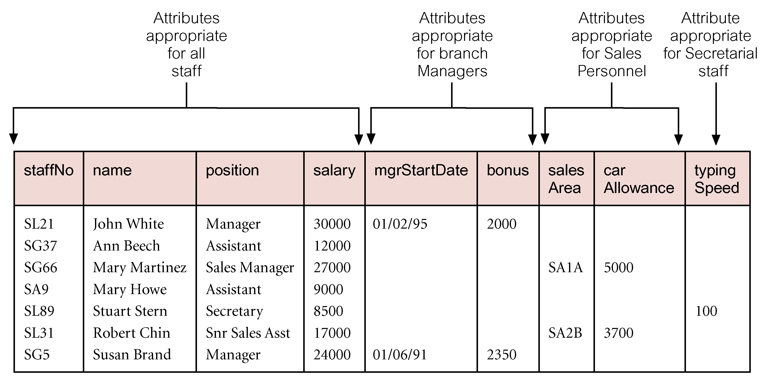

Now add in that we have different (sub) types of staff e.g. managers, sales, secretarial. We want to store different attributes for each staff type e.g. Sale staff have a sales area and car allowance attribute.
The question is, how can we transform the more complex generalisation hierarchy with these specialised attributes in a database table design?

Below is a table diagram for staff type/subtype. We have general attributes for all staff (supertype) such as name, position and salary, and specialised attributes for the Staff subtypes (managers have start date and bonus, sales have sales area and car allowance, secretarial has typing speed).

Exercise: consider this type of design from a relational model/normalisation perspective. What are the functional dependencies?

This is a single table design solution, termed a flat file. In certain circumstances, this implementation has the advantage that it can be searched quickly, as all the data is in one place (table).

However, what are the disadvantages of this single table design?

- Waste of space for all blank/null entries and possibly
- Slower search time for all staff; as all the subtype attributes in each row will slow the search.
- The implementation is a mix of concepts and doesn’t match our logical model. Effectively the subtype classes are hidden, buried in the supertype. Extending the system e.g. by adding new subtypes is much more difficult. This design is therefore said to lack extensibility.

The “one table approach” places all subtype attributes in one ‘super’ table ie. the single table is storing all the attributes for the general attributes for the supertype Staff and the specialised attributes for the subtypes of Staff (managers, sales, secretarial). Each record in the supertype table only uses attributes pertinent to its subtype; the other attribute values are left NULL.

The standard approach to map all objects to tables i.e. map the supertype and subtypes to separate tables. All of the tables will have the same primary key, so that they are linked and can be processed in queries and reports. See Diagram on page 3.

This is another situation where we see that foreign keys are used in the DB implementation of a modelling concept.

The supertype stores the primary key identifier and all common attributes and an extra attribute for Type. The subtype stores the primary key/id and all specific attributes for that specific sub type. So we have separate tables for each subtype. The identity of an object preserved through the use of the shared primary key/Id. NB a foreign key link that can be controlled via referential integrity.

Exercise 2: go back and examine the UML diagram on page 3. Identify the type/subtype element of the diagram. Think about the similarities between that type/subtype and the staff type/subtype.

Problems with Modelling.

Modelling suffers from 1. Over simplification and 2. Over-elaboration.

In modelling, designers frequently produce too few or too many objects and defining associations that do not reflect the real world application being modelled i.e. over simplification or over elaboration.

Modelling is abstract, dealing with language descriptions that are notoriously vague and open to (mis)interpretation. Recall the technique of analysing the text for nouns and verbs.

Over simplification usually results in objects that are merged/mixed together into one. Or we may be missing an important association link. From our Normalisation section, we’d expect to see redundancy in this type of oversimplified design (with its associated problems). That is, a lower normal form.

Over elaboration usually resulting in objects that are not viable (from a data perspective). These will generate extra tables (un-necessary) which will result in extra processing (disk processing).

One way to understand this is thinking about the various ways we could organise 3 basic objects : student, lecturer and module. (In class exercise). Some designers will overdo the number of links; others will not specify enough. (over elaboration or over simplification)

Some people find that the concepts and rules used in normalisation are confusing, others find the rigour of the approach helpful. i.e. there are precise design rules and definitions that can be applied.

Detail on common problems found in Modelling is in the appendix (check in class if needed)

Compare/contrast this with our design methodology for relational DBMS (normalisation)

Normalisation usually works by analysing patterns within actual existing data. Patterns reveal dependencies between different items of data. The design process organises the dependencies. Design rules, called Normal Forms, exist that prohibit certain types of dependencies appearing in a table. Each rule (normal form) is stronger as it adds new restrictions/constraints.

Nomalisation is a process that progressively refines the table(s) used in the database so that at each stage (called normal form) the set of tables that currently are used to store the data adhere to certain rules/constraints. We can think of the design process as taking a disorganised table and at each stage/normal form, we refine the organisation into a set of smaller tables. The new design models the basic elements of data better (from a data processing perspective) e.g. we identify a group of attributes that represent an object like a supplier, and that can be processed independently for insert, update etc.

The main theme of normalisation is to reduce redundancy/duplication or at least control redundancy by using concepts such as dependencies and keys.

So both approaches are useful and complementary (can work together).

Where data is unavailable, the designer may model first, then compile dummy data and then check or validate the design using the more rigorous rules of normalisation.

In many of our designs we have identified *:* associations going from 1NF to 2NF
e.g. Supplier Supplies Part, Student Enrols Course, Customer Orders Product. All of these exhibit partial dependencies because usually we see the keys of the participating objects used as a composite key in the association table. Therefore, if you use one table for these 3 concepts, you always have partial dependencies.
In Design 2 and design 4, we see transitive dependencies, which are embedded dependencies outside the key. These are 1:* associations, where 2 tables should be made with the key of one buried in the table attributes of the other.

Learning outcomes: Can you describe/explain?

- Basic concepts used in modelling, giving examples?
- What is UML?
- Does database system design require all of the features of UML? Explain.
- Does UML design database tables?
- Difference between modelling and normalisation?
- Explain the modelling concepts of Inheritance; Extensibility;
- Advantages of Modelling
- When would you recommend the use of Modelling?
- Problem(s) with modelling
- What does multiplicity mean in UML, describe using examples.
- How are associations with different multiplicities transformed into table designs?
- Supertype and subtype hierarchies. What are they and how can they be implemented in relational database systems i.e. how are they transformed into a table design.

Questions based on Appendix

- Specific problems with Modelling include Chasm and Fan traps, Explain using examples.
- Multiplicity is made up of two concepts; participation and cardinality, explain using examples.
- SuperType/SubType designs? Describe using an example; (generalisation/specialisation hierarchy)

http://www.information-management.com/infodirect/20030123/6268-1.html
http://www.ibm.com/developerworks/rational/library/content/RationalEdge/sep04/bell/
http://en.wikipedia.org/wiki/Unified_Modeling_Language

Appendix

Design 4 List. From a modelling perspective, the problem for this design is whether you include the notion of line item or not.
_____________________________________________________________________________

Problems may arise when designing a data model. These are called connection traps.

Connection traps often occur due to a misinterpretation of the meaning of certain relationships. Check in class if these are required for the exam:

Two main types of connection traps are called:

1. Fan traps - where a model represents a relationship between entity types, but pathway between certain entity occurrences is ambiguous.

2. Chasm traps - where a model suggests the existence of a relationship between entity types, but pathway does not exist between certain entity occurrences.

1. Fan Trap
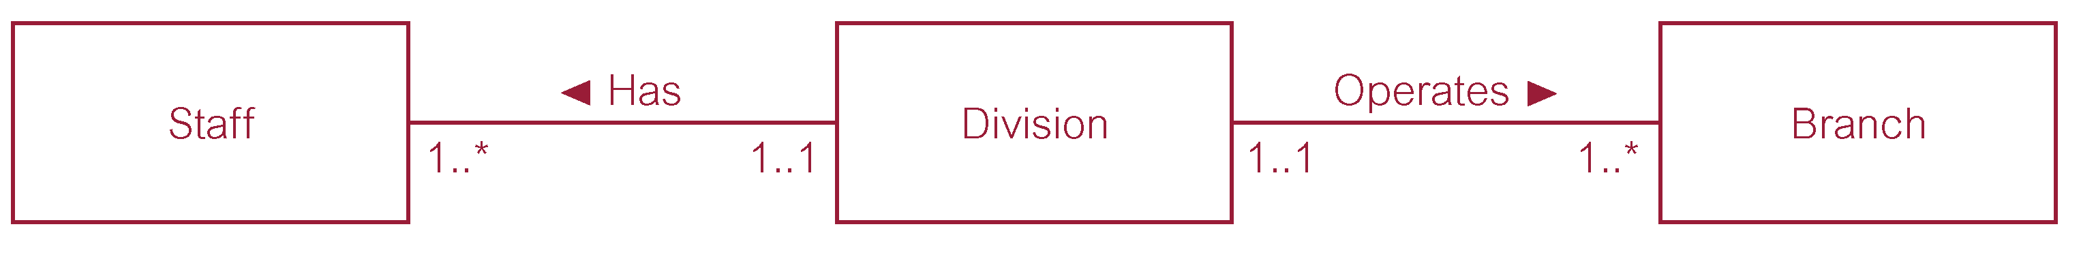
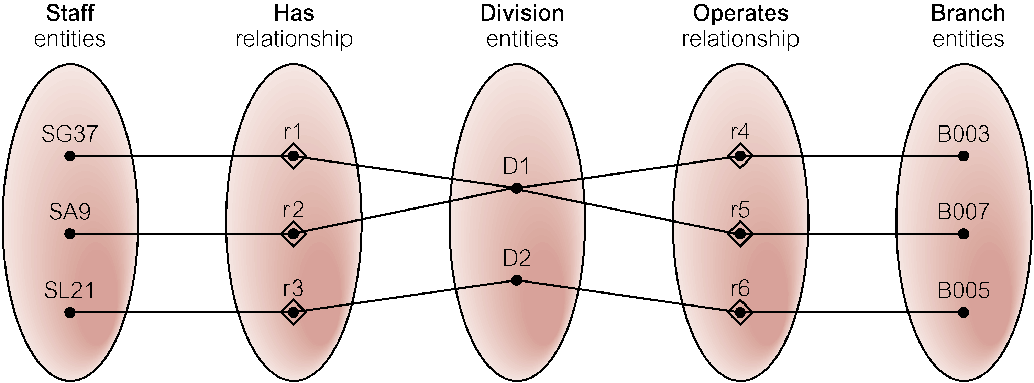

Problem caused by fan trap: At which branch office does staff number SG37 work?

Q: How to resolve Fan Trap? Answer: Restructure

Example: Restructuring Model to Remove Fan Trap ie. re arrange branch and division
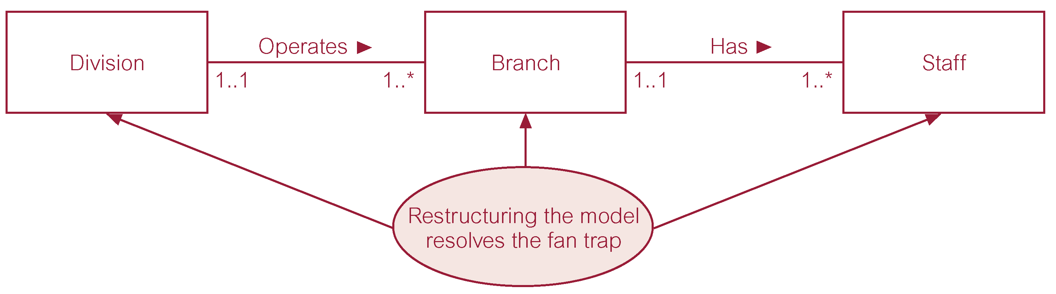
An Example of a Chasm Trap

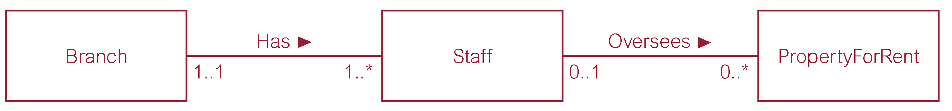

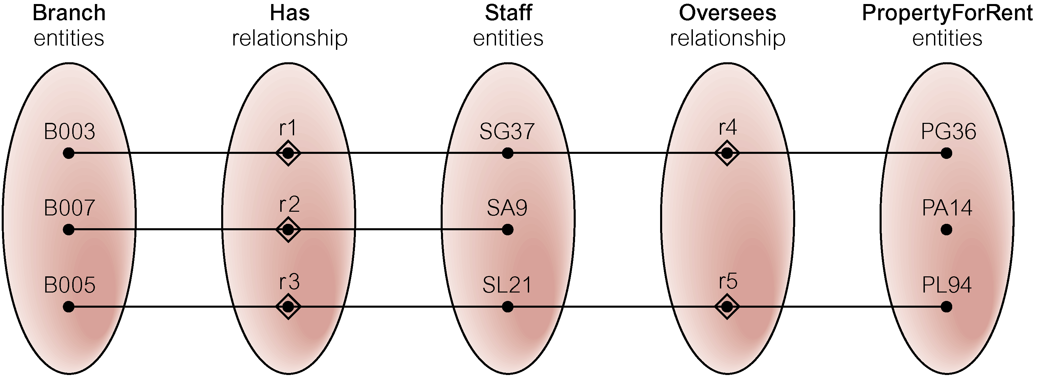

Problem: At which branch is property PA14 available? Unknown until Staff No assigned!

Solution to Chasm trap: Restructure / Add relationship to Remove Chasm Trap
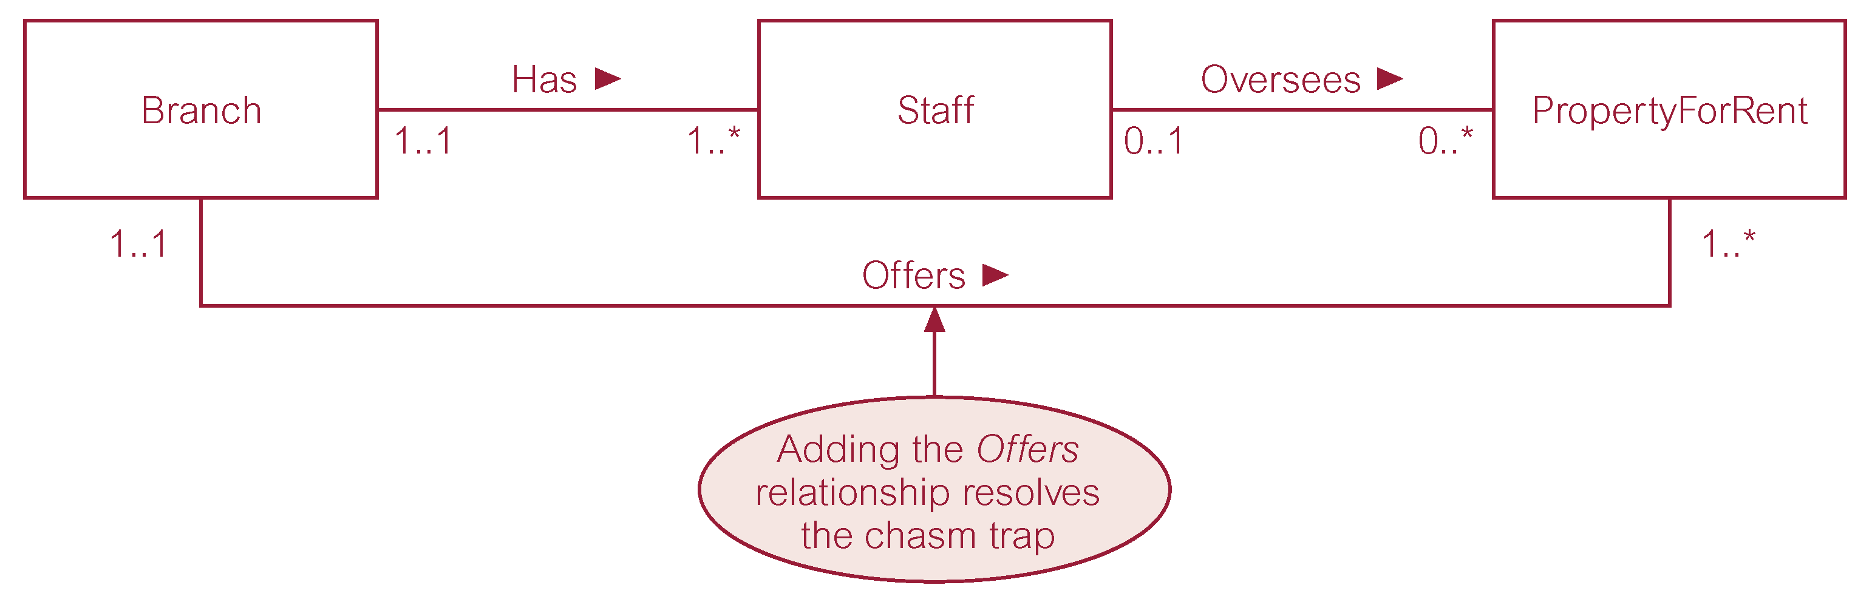
The degree of a relationship is the number of participating entity types in the relationship. Unary = 1, binary = 2, ternary = 3 etc.

Existence dependency: (Check in class if these are to be covered)

In modelling, some objects can only occur if another object exists first.
- Strong Entity Type
  - Is an entity type that exists independently of other entity types.
  - A characteristic of a strong entity type is that each entity occurrence is uniquely identifiable using the primary key attribute(s) of that entity type.
  - Is sometimes referred to as a parent, owner or dominant entity.

- Weak Entity Type
  - Is an entity type whose existence depends on some other entity type.
  - A characteristic of a weak entity type is that each entity occurrence cannot be uniquely identified using only the attributes associated with that entity type.
  - Is sometimes referred to as child, dependent or subordinate entity.
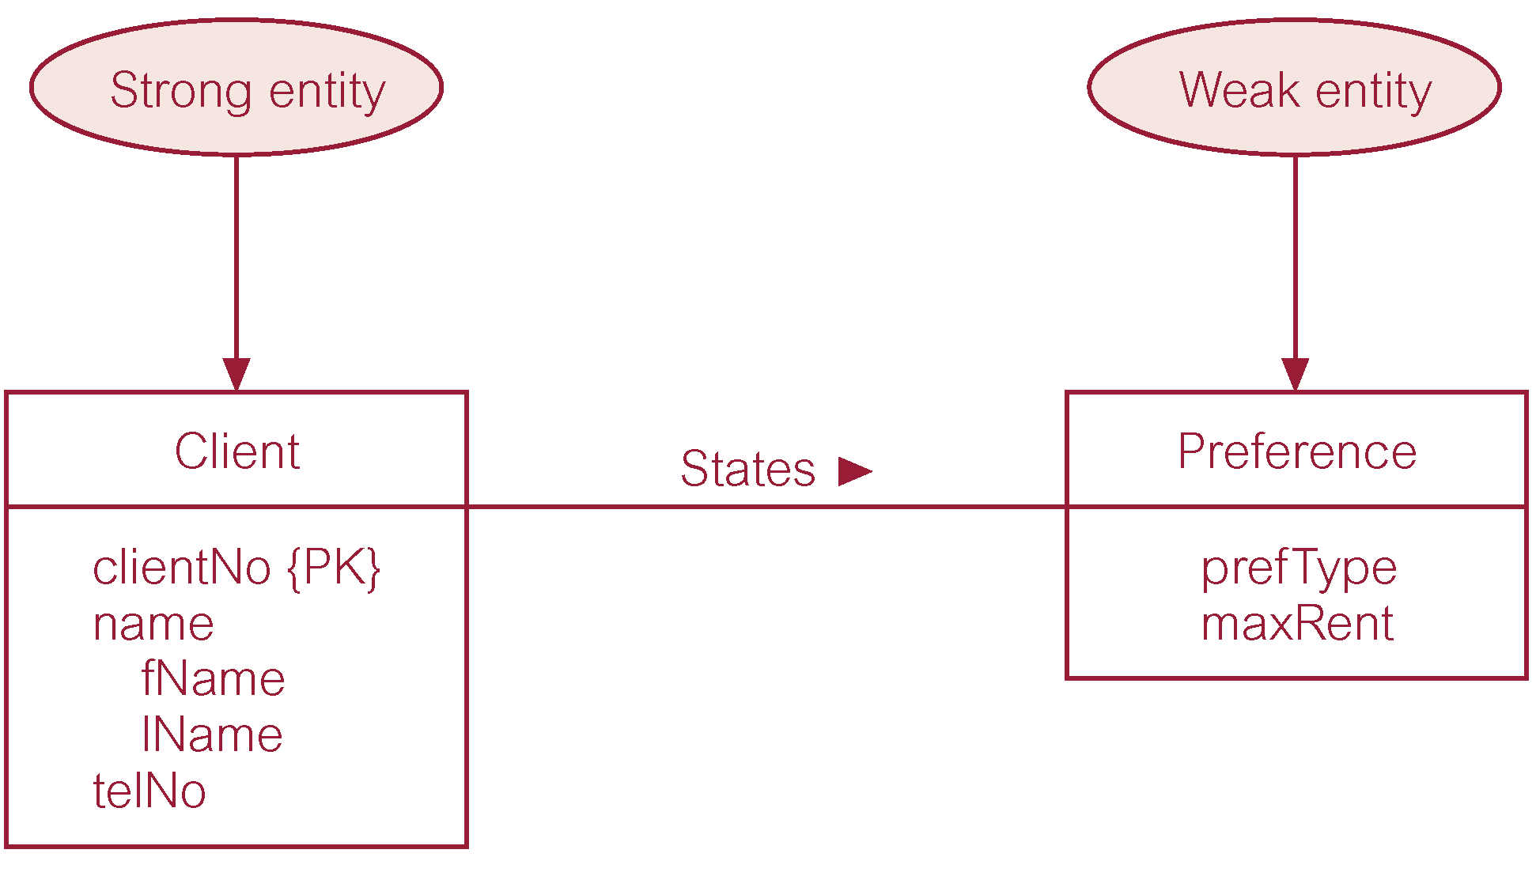

Multiplicity is made up of two types of restrictions on relationships:

- Participation Constraints
- Cardinality Constraints (this is the only element we’ve used in our simplified version)

Participation Constraints in Associations

Participation determines whether all or only some entity occurrences participate in a relationship. We think of this as participation being ‘mandatory’ (for all) or ‘optional’ (for some)

Cardinality describes the maximum number of possible relationship occurrences for an entity participating in a given relationship type.

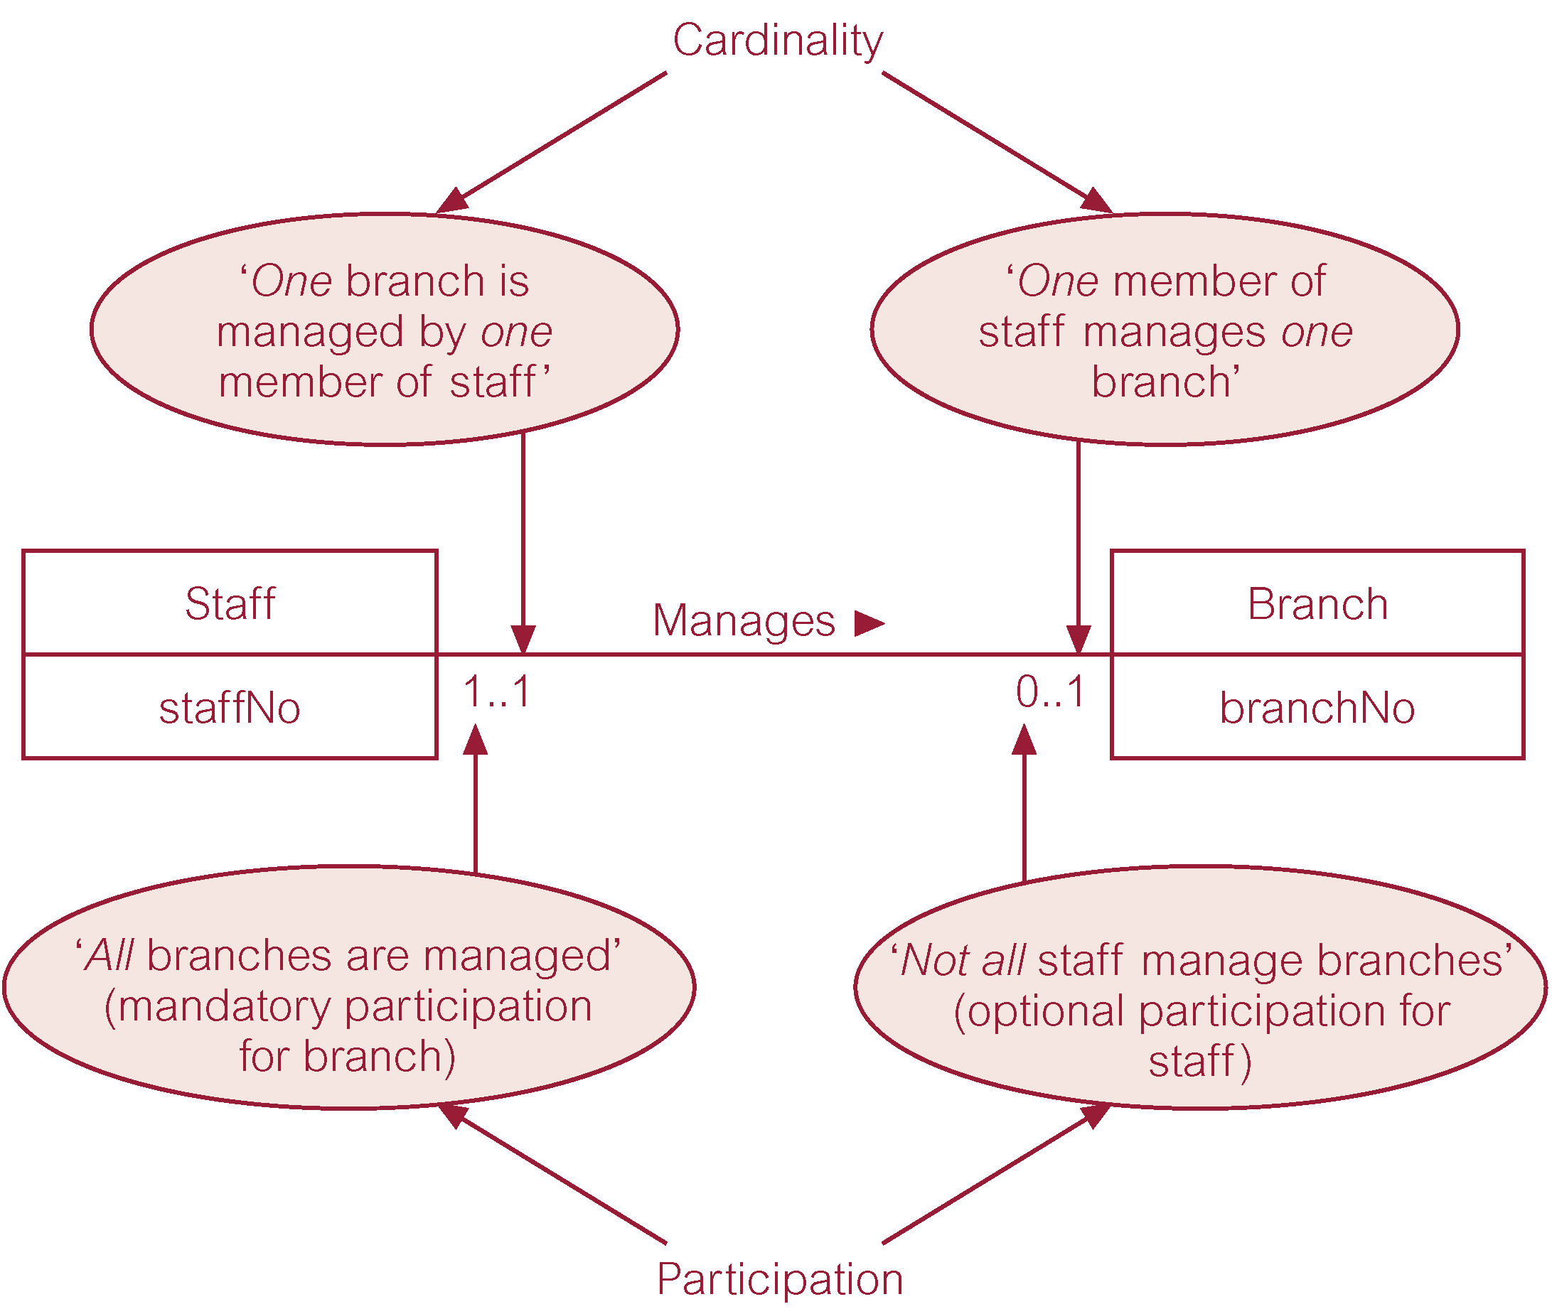
Exercise: how can optional and mandatory participation be implemented in the relational database model?

Solution to Exercise on Generalisation/Specialisation:

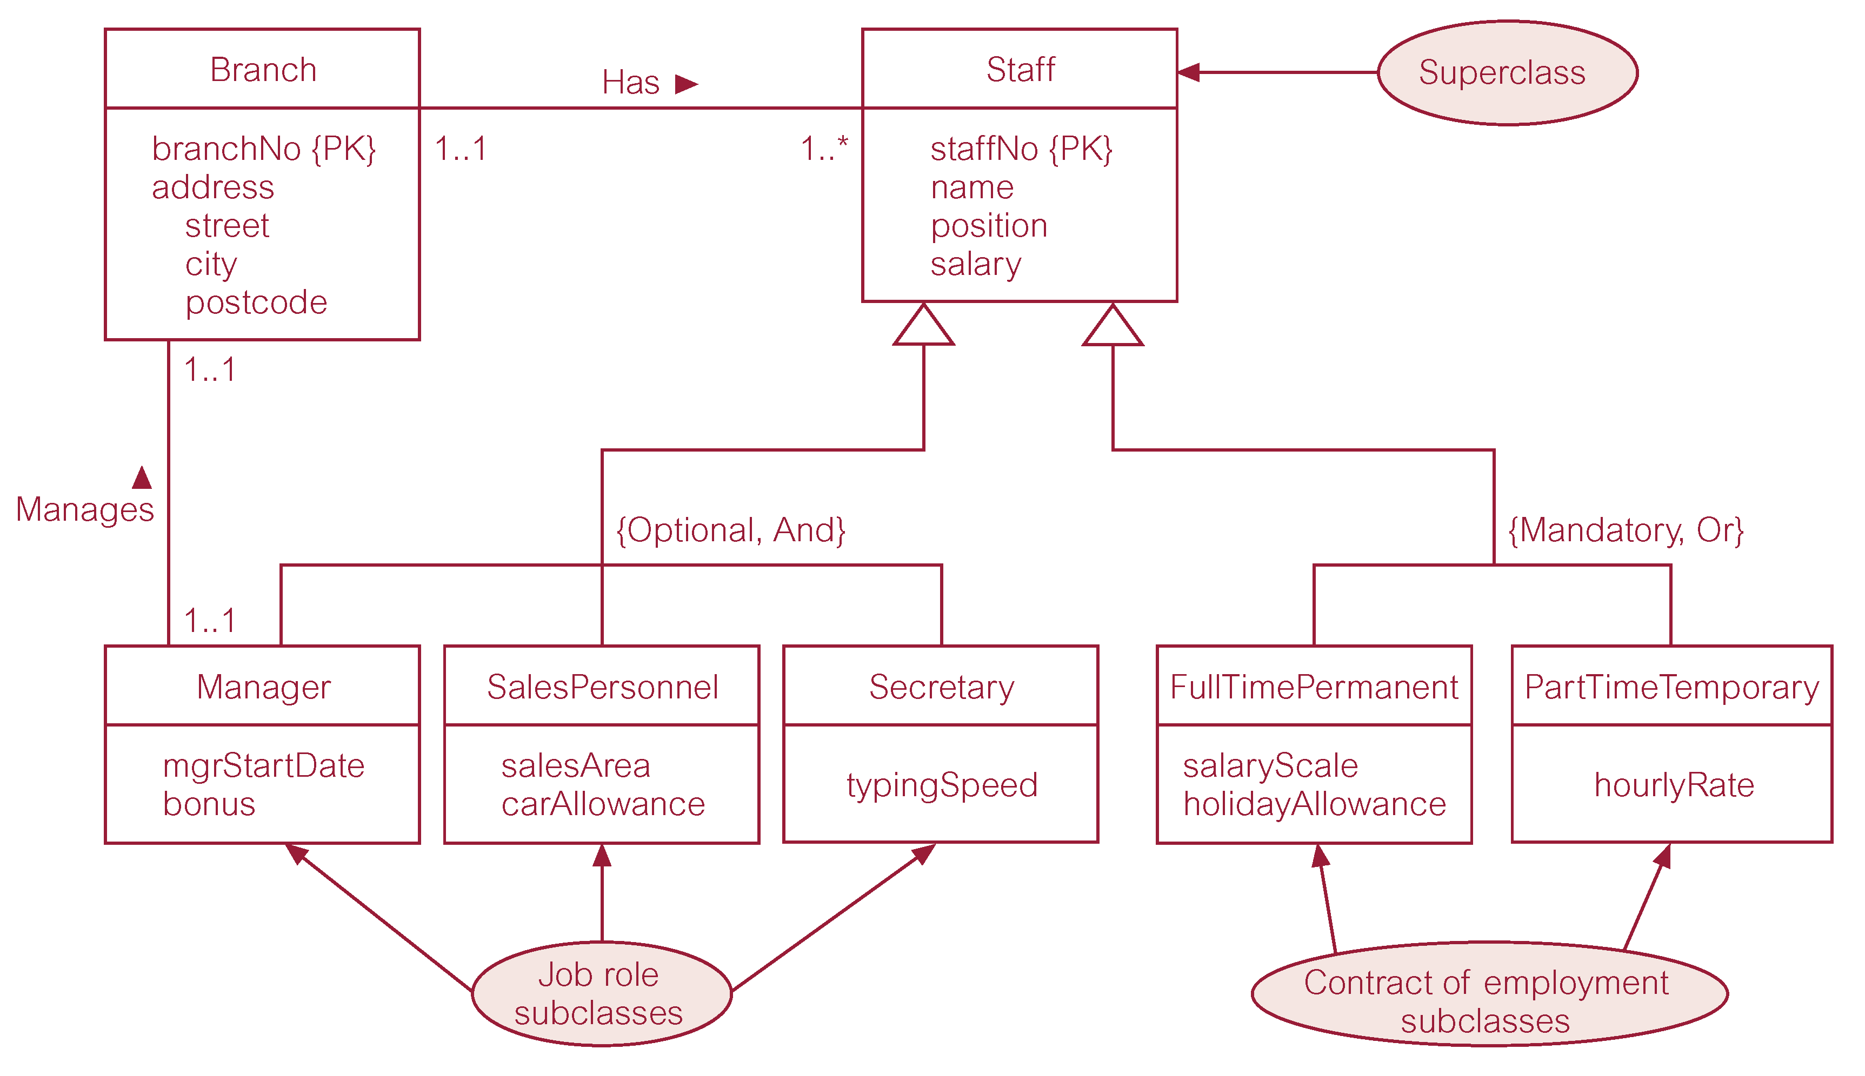

Note extra subtypes of Full time and Part time: The difference between these and the other subtypes of Staff is that, each staff member MUST be (mandatory) either Full time or Part time, whereas only some staff are (Managers, Sales, Secretary) (Optional) i.e. there are other types of Staff (Cleck, Administrator etc) and these are completely described the the normal attributes in the superclass table so there are no specialised subtypes for them.

Extra note on 1:1 associations
In the UML diagram on page 3 we have the following 1:1 association, representing a fact that a given client (i.e.1 client) can state 1 preference. A Client states one preference and each preference is unique (not reusable by other clients).

We know that DB implement both N:M and N:1 associations, albeit in different ways. How do databases handle 1:1 associations?

Firstly we need to understand that most 1:1 association are trivial (simple). They are attributes of an object e.g. a Primary key Sno will have 1 name, 1 status and 1 address etc. We do not generate individual objects (or tables) for them. So why is there a preference object above?

In this application, Preference is optional; only some clients state a preference. So it behaves like a type/subtype. The specialised attributes are taken out into a subtype object linked by the same key.

Other aspect to note that the designer may need to take a different design approach: extensibility and interoperability. If you bury the Preference object in the Client as an attribute then it is no longer visible to future extensions and programs interacting with that fact. So ask yourself, is the preference object a viable object now or in the future. Examine: Process (ins, upd, del, select) , Identifier, descriptor attributes and multiple instances!

So a DB designer may decide to bury the 1:1 association in the main object table, just like the other attributes that describe that objects. Some rows may have null entries if optional.

